Experiment 1.3
Title
Creating an Artificial Neural Network Class and Applying the Sigmoid Function

Aim
To create an Artificial Neural Network (ANN) class using Python, train the model using a simple dataset, apply the Sigmoid activation function, and predict outputs for new inputs.

Theory
An Artificial Neural Network (ANN) is a computational model inspired by the human brain. It consists of interconnected neurons that process input data and learn patterns by adjusting weights during training.
In this experiment, a single neuron is implemented using Python without any deep learning libraries. The neuron learns by repeatedly comparing its predicted output with the expected output and adjusting its weights using the error obtained.
The experiment uses the NumPy library for performing mathematical operations such as matrix multiplication and random number generation.
Important NumPy functions used are:
- np.random.random() – Generates random weight values.
- np.array() – Creates arrays or matrices.
- np.dot() – Performs matrix multiplication.
- np.exp() – Computes the exponential function used in the Sigmoid function.
The Sigmoid Activation Function converts any real value into a value between 0 and 1. It is defined as:
$$σ\left(x\right)=\frac{1}{1+e^{-x}}$$
The derivative of the sigmoid function is:
$$σ^{'}\left(x\right)=x\left(1-x\right)$$
This derivative is used during backpropagation to update the weights of the neural network.
During training:
- Input data is passed through the neuron.
- The predicted output is calculated.
- The error is computed by comparing predicted and actual outputs.
- Weights are adjusted using the sigmoid derivative.
- This process is repeated for 15,000 iterations to improve prediction accuracy.

Procedure
- Import the NumPy library.
- Create a NeuralNetwork class.
- Initialize random synaptic weights.
- Define the Sigmoid activation function.
- Define the Sigmoid derivative function.
- Create the training function to update weights using backpropagation.
- Create the prediction (think) function.
- Define the training dataset.
- Train the neural network for 15,000 iterations.
- Display the updated weights.
- Accept three user inputs.
- Predict and display the output for the new input.

Code
import numpy as np

class NeuralNetwork():

def __init__(self):
np.random.seed(1)
self.synaptic_weights = 2 * np.random.random((3, 1)) - 1

def sigmoid(self, x):
return 1 / (1 + np.exp(-x))

def sigmoid_derivative(self, x):
return x * (1 - x)

def train(self, training_inputs, training_outputs, training_iterations):

for iteration in range(training_iterations):

output = self.think(training_inputs)

error = training_outputs - output

adjustments = np.dot(
training_inputs.T,
error * self.sigmoid_derivative(output)
)

self.synaptic_weights += adjustments

def think(self, inputs):

inputs = inputs.astype(float

print("Ending Weights After Training:")
print(neural_network.synaptic_weights)

user_input_one = input("User Input One: ")
user_input_two = input("User Input Two: ")
user_input_three = input("User Input Three: ")

print("Considering New Situation:",
user_input_one,
user_input_two,
user_input_three)

print("New Output Data:")

print(neural_network.think(
np.array([
user_input_one,
user_input_two,
user_input_three
])
))

print("Done")

Sample Output
Beginning Randomly Generated Weights:

[[-0.16595599]
[ 0.44064899]
[-0.99977125]]

Ending Weights After Training:

[[10.38040701]
[-0.20641179]
[-4.98452047]]

User Input One: 1
User Input Two: 0
User Input Three: 1

Considering New Situation: 1 0 1

New Output Data:
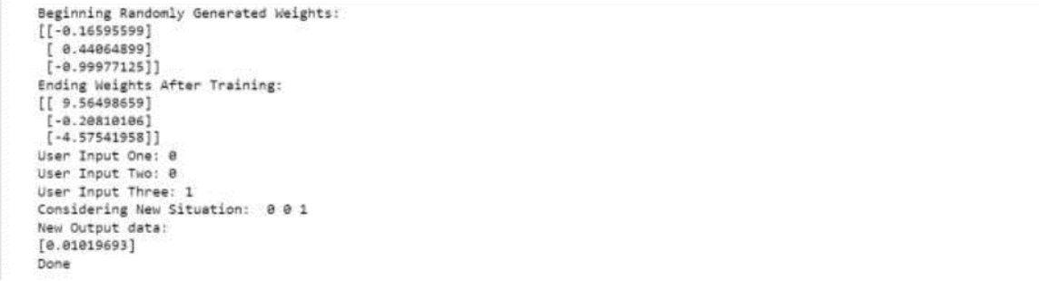
DoneLearning Outcomes
After completing this experiment, we are able to:
- Understand the basic architecture of an Artificial Neural Network (ANN).
- Implement a simple neural network using Python and NumPy.
- Apply the Sigmoid activation function and its derivative.
- Train a neural network using forward propagation and backpropagation.

